Ola Rides Analysis
Executive Data Analysis Report
Executive Summary
This report analyses Ola ride bookings in the Delhi NCR region. The data reveals a stable but constrained performance:
- 62% of bookings are successfully completed
- 18% are cancelled by drivers — the largest single source of failed trips
- Success rate remains almost constant (~61.5–62.6%) across days, months, and seasons
- A small set of routes dominate both volume and customer ratings
- High-volume / high-rated routes are not the highest revenue generators
- Auto, Go Mini, and Go Sedan account for the majority of bookings
The business has consistent demand and strong ratings on key corridors, but significant value is lost after the booking is made — primarily through driver cancellations and failure to find drivers.
1. Data Preparation & Cleaning
Tools used: Pandas, NumPy, Seaborn, Matplotlib
Key cleaning steps performed:
- Inspected structure (column names, data types, and missing value percentages)
- Filled missing values before data type conversion to preserve dataset structure
- Converted float columns to string where appropriate
- Converted date columns from string to datetime
- Validated the cleaning process (missing values, data types, and outlier checks)
The cleaned dataset provided a reliable foundation for the analysis below.
2. Booking Status Performance
Booking Status | Approximate Share | Insight
Completed | 62% | Core successful trips
Cancelled by Driver | 18% | Largest leakage point
Cancelled by Customer | ~7% | Moderate
No Driver Found | ~7% | Supply gap
Incomplete | ~6% | Process friction

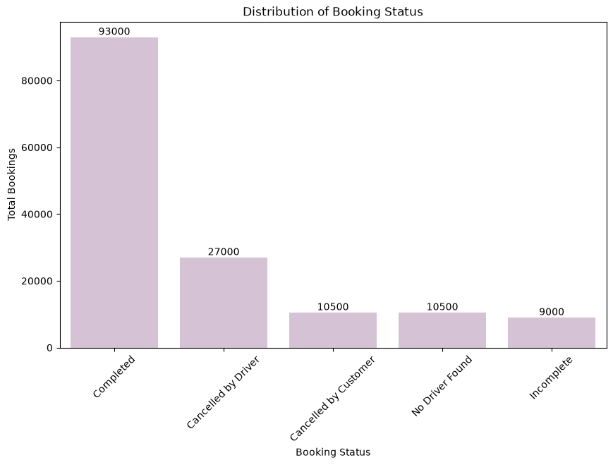
Key Insight:
Nearly 1 in 5 bookings is cancelled by the driver. Combined with “No Driver Found,” over 25% of potential trips fail due to supply-side issues.
3. Success Rate Stability
The success rate remains remarkably stable:
- Daily: 61.5% – 62.4%
- Monthly: 61.5% – 62.6%
- No meaningful variation by day of week, month, or season
Implication: The 62% completion rate appears to be a structural ceiling rather than a temporary or seasonal issue. Improvement will require operational changes, not just demand generation.
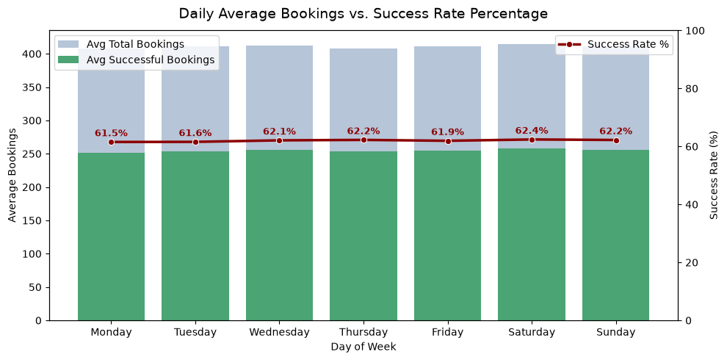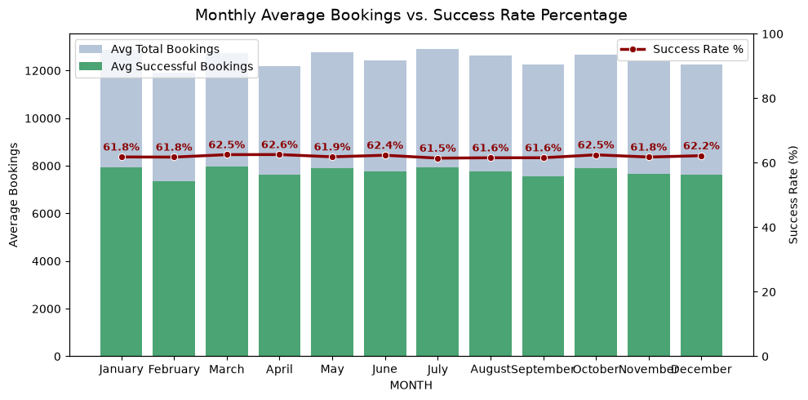
4. Route Performance
Top Booked Routes (by volume)
- DLF City Court → Bhiwadi (17 bookings)
- Akshardham → RK Puram (16)
- Janakpuri → Faridabad Sector 15 (16)
- Several routes tied at 15 bookings (Vatika Chowk → Rithala, Rithala → Udyog Vihar Phase 4, etc.)
Top Rated Routes (Min 15+ bookings)
Rank | Route | Avg. Rating
1 | Ghaziabad → Badshahpur | 4.692
2 | Akshardham → RK Puram | 4.663
3 | Janakpuri → Faridabad Sector 15 | 4.62
4 | Jor Bagh → Rohini East | 4.58
5 | Vatika Chowk → Rithala | 4.58

Important Correlation:
Several high-volume routes are also high-rated (especially Akshardham → RK Puram and Janakpuri → Faridabad). These corridors deliver both demand and customer satisfaction.
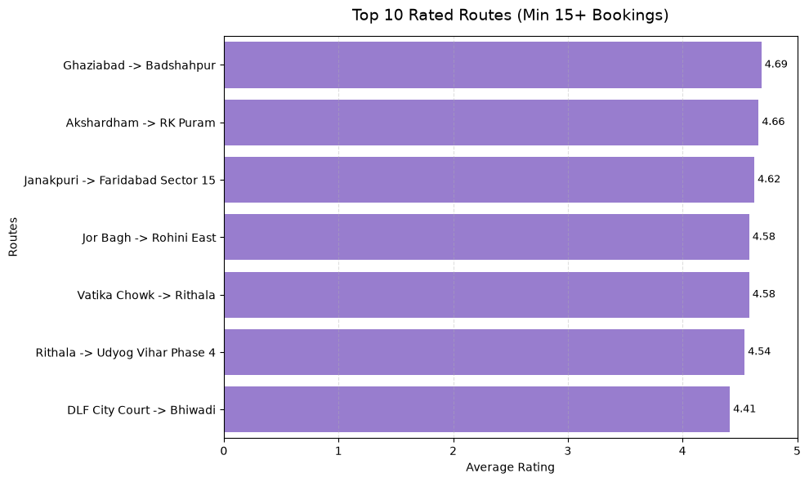
Revenue vs Popularity:
The highest-revenue routes differ from the most popular/high-rated ones. Longer-distance routes (e.g., Munirka → Bahadurgarh, IMT Manesar → Udyog Vihar) generate more revenue per trip despite lower booking volume.
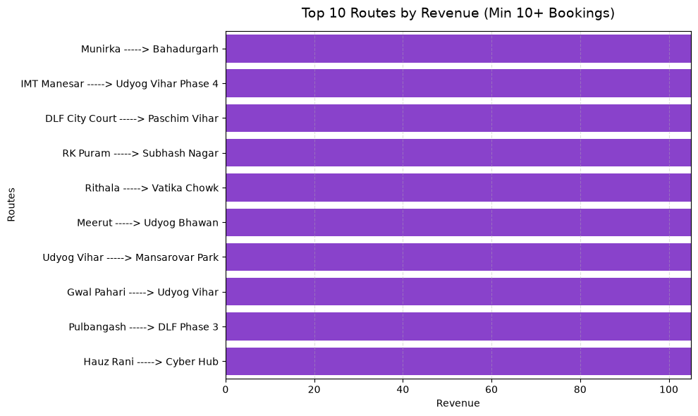
5. Vehicle Type Insights
- Most popular vehicles: Auto, Go Mini, and Go Sedan
- Success rate across vehicle types remains ~62%
- Vehicle type does not significantly influence completion rate
- Auto carries the highest absolute volume of bookings
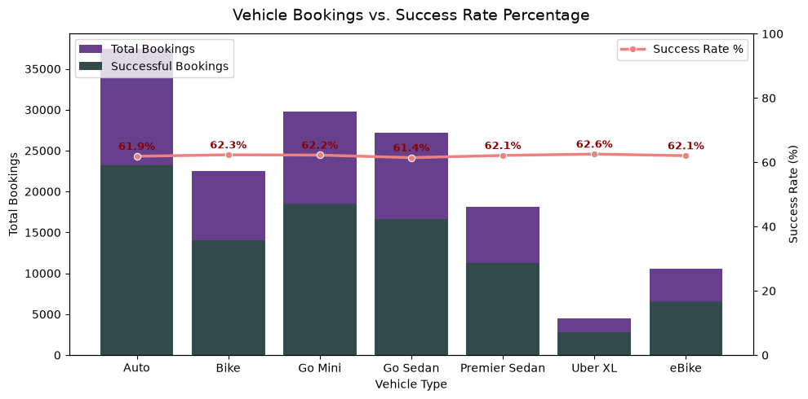
6. Key Business Implications
Finding Business Implication
18% driver cancellations Major revenue and customer experience leakage
Flat 62% success rate Structural problem — needs operational intervention
High-rated + high-volume routes Strong corridors that should be protected and promoted
Popular routes ≠ top revenue routes Longer trips are more profitable; pricing/incentives matter
Stable performance across time Demand is consistent; supply and fulfilment are the constraint
7. Strategic Recommendations
- Reduce Driver Cancellations (Highest Priority)
Investigate root causes (long pickup distance, low fares, traffic, driver incentives) and introduce targeted interventions.
- Improve Driver Supply on High-Demand Corridors
Focus on routes with elevated “No Driver Found” rates, particularly during peak periods.
- Leverage High-Performing Routes
Protect and promote corridors that combine high volume + high ratings (Akshardham–RK Puram, Janakpuri–Faridabad, Ghaziabad–Badshahpur).
- Optimise Revenue on Longer Routes
Analyse pricing, commissions, and incentives on high-revenue (longer-distance) routes to maximise contribution margin.
- Deep-dive into “Unknown” Cancellation Reasons
Current data shows many cancellation reasons as unknown. Better reason capture will enable more precise action.
- Maintain Focus on Auto, Mini & Sedan
These categories already dominate volume and should remain the core of supply strategy.
Conclusion
Ola’s Delhi NCR operations show healthy and stable demand with strong customer ratings on key routes. However, the business is leaving significant value on the table: only 62% of bookings are completed, and driver cancellations alone account for 18% of all bookings.
The highest-impact opportunity is clear — fix the post-booking fulfilment problem, especially driver cancellations and driver availability. Doing so on the already popular and highly rated corridors would improve both revenue and customer experience simultaneously.

